# CS 340 README – Project One

## About the Project/Project Title

The project is a software application that identifies and categorizes dogs based on multiple factors to determine which dogs would be eligible for training.

## Motivation

The purpose of this project is to connect an international rescue-animal training company with animal shelters, eligible dogs will be trained and be used to find and help rescue humans or other animals in life threatening conditions. The dogs will be used in different types of scenarios including rescue, water rescue, mountain or wilderness rescue, tracking, and much more. The main purpose of this project is to develop a data table and display a pie sheet as well as sort based on the type of dog needed.

## Getting Started

To develop a data table, pie chart, map and more follow these steps:

Inserting the correct components and references:

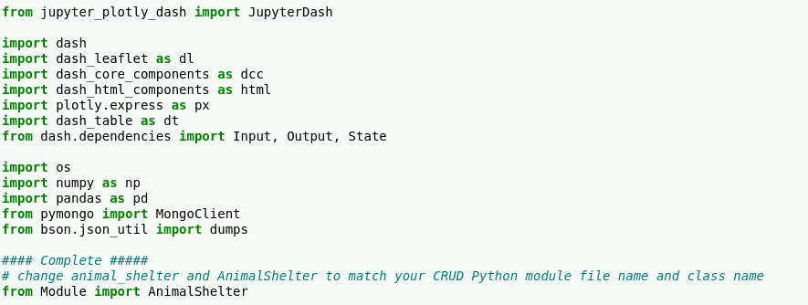

Creating an application that displays the Grazioso Salvare’s Logo:

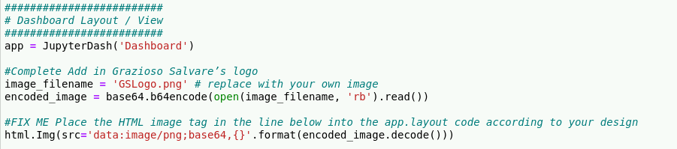

## Installation

The tools need for this project are as followed:

Mongo database

Python IDE

Data file that has the required information

## Usage

### Screenshots

Below is the code needed for creating buttons, pie charts, and a mapping system.

Adding a tag as well as buttons:

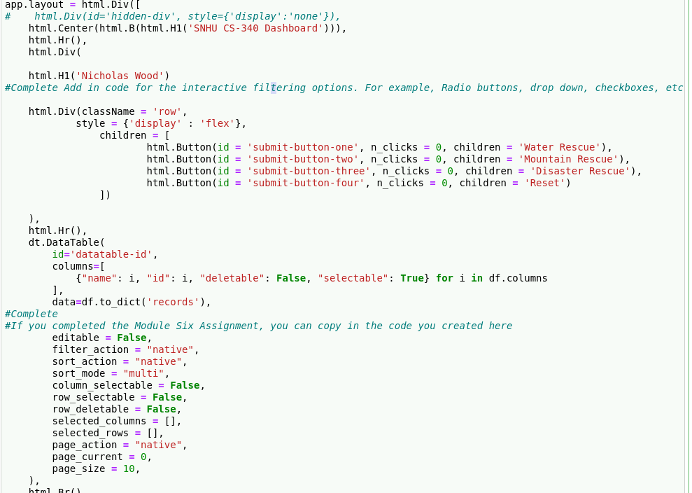

Continuing the button development and dashboard:

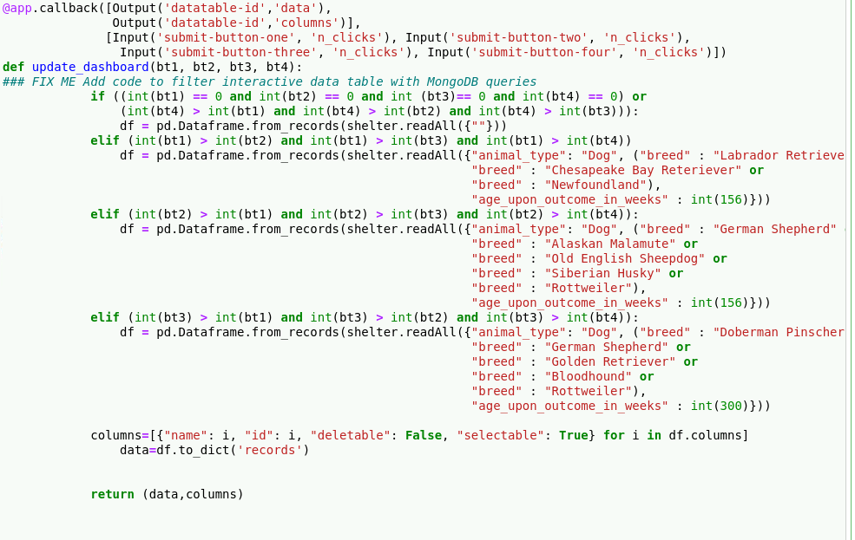

Adding the pie chart and the mapping:

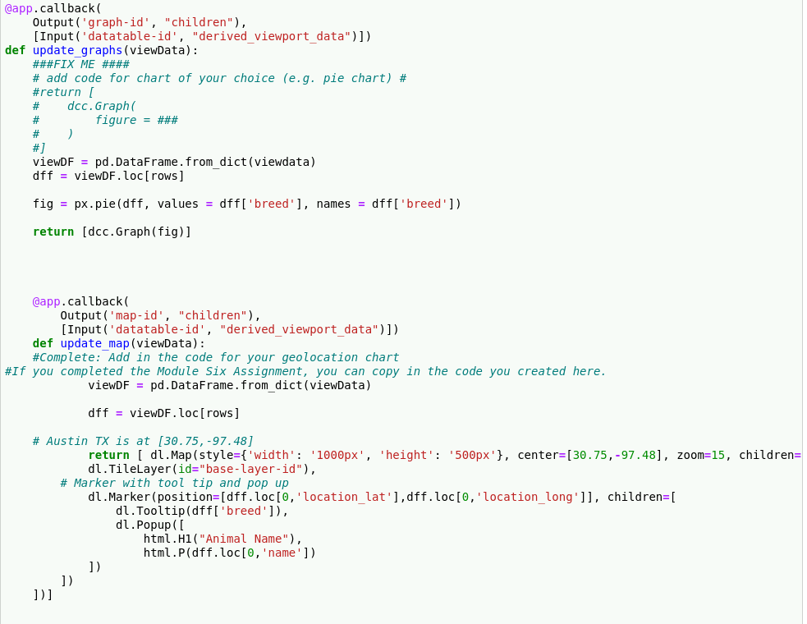

Unfortunately, the program is not working correctly, I have been through many iterations but have been unable to create a working program. I believe the pieces are there but there is some minor errors that I am unable to fix.

## Contact

Nicholas Wood

Nicholas.wood3@snhu.edu